NoteHub: Smart YouTube Video Notes Generator
By

Saad Arham 2022-GCUF-07017
M.Faizan Zafar 2021-GCUF-07031
Mujahid Mehmood 2022-GCUF-07015

Project submitted in partial fulfillment of the requirements for the Degree of

Bachelor of Science
IN

Computer Science

DEPARTMENT OF COMPUTER SCIENCE
GOVERNMENT COLLEGE UNIVERSITY, FAISALABAD
DEC-2025

DEDICATION

This project is dedicated to my beloved parents, whose love, prayers, and guidance have always been my greatest source of strength. Their encouragement has inspired me to strive for excellence in all that I do.

SAAD ARHAM
M. FAIZAN ZAFAR
MUJAHID MEHMOOD

DECLARATION

I hereby declare that the content of the project, “Note Hub”, are product of my own research and no part has been copied from any published source (except the references, some standard mathematical or genetic models/equations/protocols etc). I further declare that this work has not been submitted for award of any other diploma/degree. The university can take action if the above statement is found inaccurate at any stage.

Signature of the Students

Name: SAAD ARHAM

Registration No.: 2022-GCUF-07017

Signature of the Student

Name: M.FAIZAN ZAFAR

Registration No.: 2021-GCUF-07031

Signature of the Students

Name: MUJAHID MEHMOOD

Registration No.: 2022-GCUF-07015

CERTIFICATE BY SUPERVISORY COMMITTEE
This is to certify that the project report entitled "Note Hub", which is submitted by SAAD ARHAM Registration No. 2022-GCUF-07017 and M. FAIZAN ZAFAR Registration No. 2021-GCUF-07031 and MUJAHID MEHMOOD Registration No. 2022-GCUF-07015 has been examined by the undersigned as a part of the examination for the award of the degree of Bachelor of Computer Science from Government College University Faisalabad, Pakistan.

Supervisor: ______________________________
Rao Sohail Iqbal Asif
Lecturer
Department of Computer Science, GCUF

Member: ______________________________
Sheikh Muhammad Aamir
Lecturer
Department of Computer Science, GCUF

Chairperson: ______________________________
Dr. Muhammad Kashif Hanif
Chairman
Department of Computer Science, GCUF

Table of Contents
CHAPTER 1 – INTRODUCTION TO THE PROBLEM 1
1.1 Introduction 1
1.2 Background 1
1.3 Purpose 2
1.4 Scope 2
1.5 Objectives 2
CHAPTER 2 -SOFTWARE REQUIREMENT SPECIFICATION 4
2.1 Overall Description 4
2.1.1 Product Perspective 4
2.1.2 Product Features 4
2.1.3 Design and Implementation Constraints 5
2.1.4 Assumptions and Dependencies 5
2.2 System Features 5
2.2.1 YouTube Video Link Submission 5
2.2.2 Video Metadata Retrieval 6
2.2.3 Transcript Extraction Module 6
2.2.4 Text Cleaning and Preprocessing 7
2.2.5 AI-Based Notes Generation 7
2.2.6 Keyword Extraction 8
2.2.7 Timestamp Linking 8
2.2.8 Quiz Generation Module 9
2.2.9 Quiz Attempt and Evaluation 9
2.2.10 Progress Tracking System 10
2.2.11 AI Study Assistant 10
2.2.12 User Dashboard Management 11
2.3 External Interface Requirements 11
2.3.1 User Interfaces 11
2.3.2 Hardware Interfaces 11
2.3.3 Software Interfaces 12
2.3.4 Communications Interfaces 12
2.4 Other Nonfunctional Requirements 12
2.4.1 Performance Requirements 12
2.4.2 Safety Requirements 12
2.4.3 Security Requirements 12
2.4.4 Business Rules 13
CHAPTER 3 – ANALYSIS (USE CASE MODEL) 14
3.1 Identifying Actors and Use Cases 14
3.2 Use Case Diagram …………………………………………………………………...15
3.3 SYSTEM ANALYSIS (USE CASE MODEL) 16
CHAPTER 4 – DESIGN 28
4.1.1 Architecture Diagram 28
4.1.2 Entity Relationship Diagram 29
4.1.3 Data Flow Diagram (Level 0 and Level 1) 33
4.1.4 Class Diagram 35
4.1.5 Object Diagram 36
4.1.6 Sequence Diagram 37
4.1.7 Activity Diagram 38
4.1.8 Collaboration / Communication Diagram 39
4.1.9 State Transition Diagram 40
40

List of Figures
Figure 3. 1: Use Case Diagram 18
Figure 4. 1: Architecture Diagram 28
Figure 4.2: Entity Relationship Diagram 29
Figure 4.3: Data Flow Diagram Level 0 33
Figure 4.4: Data Flow Diagram Level 1 34
Figure 4. 5: Class Diagram 35
Figure 4. 6: Object Diagram 36
Figure 4.7: Sequence Diagram 37
Figure 4. 8: Activity Diagram 38
Figure 4.9: Communication Diagram 39
Figure 4. 10: State Transition Diagram 40

List of Tables
Table 3. 1: Use Case — User Registration 16
Table 3. 2: Use Case — User Login 17
Table 3. 3: Use Case — Submit YouTube Video Link 17
Table 3. 4: Use Case — Extract Transcript 18
Table 3. 5: Use Case — Text Cleaning and Preprocessing 19
Table 3. 6: Use Case — Generate AI-Based Notes 20
Table 3. 7: Use Case — Keyword Extraction 21
Table 3. 8: Use Case — Generate Quiz 21
Table 3. 9: Use Case — Attempt Quiz 22
Table 3. 10: Use Case — Track Learning Progress 23
Table 3. 11: Use Case — AI Study Assistant 23
Table 3. 12: Use Case — User Dashboard Management 24
Table 3. 13: Use Case — Admin Login 25
Table 3. 14: Use Case — Monitor System 26
Table 3. 15: Use Case — Manage Users 27
Table 4.1: Admin 29
Table 4.2: User 29
Table 4.3: Video 29
Table 4.4: Notes 30
Table 4.5:Quiz 30
Table 4.6: Progress 31
Table 4.7: Dashboard 31

CHAPTER 1 – INTRODUCTION TO THE PROBLEM
This section introduces the design of the NoteHub system. NoteHub is a platform that helps users generate structured notes, quizzes, and learning progress from YouTube videos. In this section, the overall system architecture, database design, and UML diagrams are presented to explain how the system works internally. These designs help the reader understand the structure, data flow, and interactions of different components of the system.

1.1 Introduction
In recent years, online video platforms have become an important part of learning. Among them, YouTube is widely used for free educational content such as lectures, tutorials, and concept explanations. Many students now depend on YouTube videos alongside classroom teaching to understand topics and improve their skills. However, learning from long video lectures is not always easy. Students often struggle to identify important points, write organized notes, and revise content quickly. Manual note-taking from videos requires pausing, rewinding, and writing repeatedly. This becomes time-consuming and tiring, especially when students need to prepare for exams or assignments in limited time.To solve this problem, NoteHub: Smart YouTube Video Notes Generator is proposed. This system uses AI and NLP to convert YouTube video content into structured notes automatically. It helps students save time and improves learning by generating summaries, keywords, quizzes, and study support through a web platform.

1.2 Background
The shift toward online education has increased strongly due to internet growth and easy access to smart devices. Students prefer flexible learning where they can study at their own pace. YouTube has become one of the most popular sources for educational content Because it provide structures and tutorials for almost every subject. Even though video content is useful, videos are not organized like written notes. Students often need to watch the same video multiple times to extract key points. Traditional note-taking is not best for video-based learning because students can miss important information, write unclear notes, or fail to keep a proper structure. Also, searching for specific topics inside a video is difficult without reference points. Recent advances in AI—especially NLP and text summarization—make it possible to analyze transcripts and generate meaningful summaries, keywords, and questions automatically. This project uses transcript extraction, preprocessing, and AI summarization techniques to help students learn more efficiently from video lectures.

1.3 Purpose
The purpose of NoteHub is to help students learn effectively from educational YouTube videos by reducing the effort of manual note-taking. The system automatically generates structured notes, allowing students to focus on understanding the lecture instead of stopping the video repeatedly. The project also supports active learning by providing quiz generation, timestamp linking, progress tracking, and an AI Study Assistant for concept clarification. This makes learning more interactive and improves revision and self-assessment.

1.4 Scope
NoteHub is an AI-based learning support system designed to help users learn efficiently from YouTube educational videos. The system allows users to submit a YouTube link, extract the video transcript, and preprocess the text using natural language processing techniques. Based on the processed content, NoteHub generates structured notes with headings, summaries, and bullet points. It also extracts important keywords, links them with timestamps for quick navigation, and generates quizzes to evaluate user understanding. User learning progress is tracked and displayed through a dashboard, while an AI study assistant supports users by answering questions and providing explanations. The main objectives of NoteHub are to save learning time, improve content understanding, and support self-paced learning using AI technologies. The system aligns with digital education goals by providing an intelligent and scalable learning platform. NoteHub does not support live streams, private videos, offline videos, or videos without captions. The development of a full mobile application is also outside the current scope.

1.5 Objectives
The main objective of the NoteHub system is to automatically generate structured notes from educational YouTube videos to support effective learning. By converting video content into well-organized notes, the system helps learners focus on understanding concepts rather than writing everything manually. This approach significantly reduces the time and effort required for manual note-taking. As a result, students can save valuable study time and use it more productively. The system is designed to improve learning efficiency by presenting information in a clear and concise format.

CHAPTER 2 -SOFTWARE REQUIREMENT SPECIFICATION

2.1 Overall Description
NoteHub is an AI-powered, web-based learning support system designed to help students study more effectively using YouTube educational videos. The system allows users to submit a YouTube video link, from which it automatically extracts the available transcript or captions. The extracted text is then cleaned and preprocessed to remove irrelevant content and improve accuracy. Using artificial intelligence techniques, NoteHub generates structured study notes in the form of headings, summaries, and bullet points, making complex video content easier to understand. The system also extracts important keywords and associates them with timestamps to support quick revision. In addition, NoteHub generates quizzes based on the video content to assess user understanding and tracks user progress over time. A dashboard is provided to manage notes, quizzes, and learning activities, while an AI study assistant supports users by answering questions and providing explanations. The overall goal of NoteHub is to save learning time, improve comprehension, and support self-paced learning through intelligent automation.

2.1.1 Product Perspective
NoteHub is a standalone web-based application developed using a client–server architecture to ensure scalability, reliability, and ease of maintenance. The frontend of the system is built using Next.js, which provides a responsive and interactive user interface for students to submit video links, view generated notes, attempt quizzes, and track learning progress. The backend consists of application programming interfaces (APIs) and processing modules that handle core functionalities such as transcript extraction, text preprocessing, AI-based note generation, quiz creation, and progress management. The system integrates with external services to perform specialized tasks. The YouTube Data API is used to retrieve video metadata and available transcripts, enabling the system to process educational video content accurately. AI services are employed for advanced features such as summarization, keyword extraction, quiz generation, and the AI study assistant. For data storage and user authentication, services such as Firebase or Supabase are utilized to securely manage user accounts, store generated notes, quizzes, and track user learning progress. This architecture ensures efficient data handling, secure access, and smooth interaction between system components.

2.1.2 Product Features

NoteHub provides a wide range of features to support effective learning from YouTube educational videos. The system allows users to submit and validate YouTube video links, after which it displays relevant video metadata such as the title, channel name, and duration. It extracts available video transcripts or captions and cleans the text using natural language processing techniques to remove unnecessary content and improve clarity. Based on the processed text, NoteHub generates AI-based structured notes that include headings, summaries, and bullet points for better understanding. The system also performs keyword extraction and links important concepts with timestamps, enabling users to quickly navigate to important sections of the video. In addition to note generation, NoteHub creates quizzes in the form of multiple-choice and short-answer questions to assess user understanding. User quiz attempts are evaluated instantly, and learning progress is tracked and displayed as a percentage. An AI study assistant is provided to answer user questions related to notes or video content, offering additional explanations when needed. All learning activities, including notes, quizzes, and progress, are managed through a user-friendly dashboard. Users can also download or save their generated notes for offline review. To enhance usability, the system supports both dark and light modes, allowing users to choose their preferred interface theme.

2.1.3 Design and Implementation Constraints

The NoteHub system relies on a stable internet connection to communicate with external services such as the YouTube API and AI-based processing services. These external services may have usage limits, which can affect system performance and response time. Transcript extraction depends on the availability of captions provided with YouTube videos, and videos without captions cannot be processed. Since NoteHub is a web-based application, it must remain compatible with commonly used web browsers. For security reasons, API keys used to access external services must be protected and should not be exposed on the frontend. The system should also be designed to handle delays smoothly in cases where external services respond slowly, ensuring a stable user experience.

2.1.4 Assumptions and Dependencies
Assumptions
Users provide valid public YouTube links
Users use modern browsers
Educational videos provide transcripts/captions
Dependencies
YouTube Data API (metadata + transcripts)
OpenAI API / transformer models for summarization, quiz, assistant
NLP libraries for preprocessing
Firebase/Supabase for authentication and storage

2.2 System Features

2.2.1 YouTube Video Link Submission
Description and Priority: The YouTube Video Link Submission feature serves as the starting point of the NoteHub system workflow. It allows users to provide a YouTube video URL from which study notes, quizzes, and other learning resources are generated. This feature is essential because all further processing depends on the successful submission of a valid video link. When a user enters a YouTube URL, the system checks whether the link is correctly formatted and whether the video is accessible for processing. This ensures that only supported and valid videos are accepted by the system. Due to its role as the entry point for all major functionalities, this feature is assigned a high priority.

Stimulus / Response Sequences The process is triggered when a user enters a YouTube video URL into the system. In response, the system validates the URL format and checks whether the video is publicly accessible and supported. If the URL is valid, the system allows the workflow to continue with metadata retrieval and transcript extraction. If the URL is invalid, unsupported, or inaccessible, the system displays an appropriate error message and asks the user to enter a valid YouTube link again. This ensures smooth user interaction and prevents unnecessary processing errors.
Functional Requirements REQ-1: The system shall allow users to input a YouTube video URL.
REQ-2: The system shall validate that the URL belongs to YouTube
REQ-3: The system shall verify the video is public and accessible.
REQ-4: The system shall display an error message for invalid URLs.

2.2.2 Video Metadata Retrieval
Description and Priority:
Video Metadata Retrieval is an important feature of the NoteHub system that provides users with essential information about the submitted YouTube video. After a YouTube link is successfully validated, the system retrieves video details such as the title, channel name, duration, and description using the YouTube Data API. Displaying this information helps users confirm that the correct video has been selected before further processing begins. It also improves user experience by providing clear context about the video content. Since this feature supports verification and is required before transcript extraction and AI processing, it is assigned a high priority in the system.
Stimulus/Response Sequences:
The process is triggered when a valid YouTube URL is submitted by the user. In response, the system communicates with the YouTube Data API to fetch the relevant video metadata. Once the data is successfully retrieved, the system displays the video details on the user interface. If the metadata cannot be retrieved due to an API error or network issue, the system handles the situation gracefully by informing the user.
Functional Requirements
REQ-5: The system shall fetch video title, duration, and channel name via YouTube Data API.
REQ-6: The system shall display metadata on the user interface.
REQ-7: The system shall handle API failure by showing a user-friendly message.

2.2.3 Transcript Extraction Module
Description and Priority: The Transcript Extraction Module is responsible for obtaining the captions or transcript text from the YouTube video provided by the user. This extracted transcript serves as the primary input for all AI-based processing tasks in the NoteHub system, such as text preprocessing, notes generation, keyword extraction, and quiz creation. Since the quality and availability of the transcript directly affect the accuracy of AI-generated outputs, this module is considered a high-priority component of the system.
Stimulus/Response Sequences: The process begins when the user confirms that they want to process a submitted YouTube video. This confirmation acts as the stimulus for the system to initiate transcript extraction. In response, the system sends a request to YouTube services to retrieve the available captions or transcript for the video. If the transcript is successfully retrieved, it is stored securely within the system so it can be used by subsequent modules. However, if the video does not contain captions or transcript support, the system stops further processing and informs the user accordingly. This prevents unnecessary system operations and ensures transparency for the user.
Functional Requirements
REQ-8: The system shall extract transcript from YouTube (if available).
REQ-9: The system shall notify the user if transcript/captions are not available.
REQ-10: The system shall store extracted transcript for further processing.

2.2.4 Text Cleaning and Preprocessing
Description and Priority:
This feature is responsible for preparing the extracted transcript for further processing and analysis. Once the transcript is obtained from a YouTube video, it may contain unnecessary elements such as filler words, repeated phrases, timestamps, or formatting issues. The text cleaning and preprocessing process removes these unwanted parts and organizes the content into a clear and readable form. This step improves the quality of the text so that accurate summaries, notes, and quizzes can be generated. Due to its importance in ensuring reliable AI-generated results, this feature is assigned a high priority.
Stimulus/Response Sequences: The stimulus for this process occurs when a transcript is successfully extracted from the video. In response, the system automatically cleans the text by removing stop-words, correcting formatting issues, eliminating repetitions, and organizing sentences in a structured manner. This cleaned and processed text is then forwarded to the AI modules for summarization, keyword extraction, and quiz generation. This process ensures that all subsequent features work on high-quality and well-structured input data.
Functional Requirements
REQ-11: The system shall remove repeated phrases and noise from transcript.
REQ-12: The system shall segment transcript into meaningful sentences/paragraphs.
REQ-13: The system shall prepare the cleaned text for AI processing.

2.2.5 AI-Based Notes Generation
Description and Priority: AI-Based Notes Generation is one of the core and most important features of the NoteHub system. Its main purpose is to convert cleaned and preprocessed video transcripts into structured and easy-to-understand study notes using artificial intelligence techniques. Instead of requiring users to manually watch long videos and take notes, this feature automatically summarizes the content and presents it in an organized format. The generated notes include clear headings, concise summaries, and bullet points, which help users understand key concepts quickly and revise efficiently. Due to its central role in achieving the system’s learning objectives, this feature is assigned a high priority.
Stimulus/Response Sequences: The process starts when a clean and well-structured transcript becomes available after text preprocessing. This availability acts as the stimulus for the AI notes generation module. In response, the system applies AI-based summarization techniques to analyze the transcript and identify important topics and key ideas. Based on this analysis, the system generates structured notes by organizing the content into meaningful headings, short summaries, and bullet points. Once the notes are generated, they are saved and made accessible through the user’s dashboard for later review. If the AI service fails or is unable to generate notes due to an error, the system handles the situation gracefully by displaying an appropriate error message to the user.
Functional Requirements
REQ-14: The system shall generate summarized notes from transcript using AI.
REQ-15: The system shall format notes into headings and bullet points.
REQ-16: The system shall save generated notes to the user dashboard.
REQ-17: The system shall display an error message if AI generation fails.

2.2.6 Keyword Extraction
Description and Priority:
Keyword Extraction is a feature of the NoteHub system that helps users quickly review and revise important concepts from the generated notes. After structured notes are created from a video, this feature analyzes the content to identify significant terms and phrases that represent the core ideas of the topic. Displaying keywords separately allows users to focus on essential concepts without rereading the entire notes. Since this feature supports revision rather than core processing, it is assigned a medium priority.
Stimulus/Response Sequences:
The stimulus for this feature occurs when structured notes are successfully generated by the system. In response, the system processes the notes to extract important keywords and phrases using text analysis techniques. These extracted keywords are then displayed to the user within the notes view page, enabling quick reference and efficient revision.
Functional Requirements
REQ-18: The system shall identify important keywords and phrases.
REQ-19: The system shall show keywords in the note view page.

2.2.7 Timestamp Linking

Description and Priority:
Timestamp Linking is a feature that enhances user navigation within educational videos by connecting important notes and key concepts with specific time positions in the video. This allows users to directly jump to relevant sections instead of watching the entire video again. When notes are generated from the video content, the system identifies important points and, where possible, associates them with corresponding timestamps based on the transcript and video metadata. This feature improves learning efficiency and supports quick revision. Since it adds convenience but is not critical to core processing, this feature is assigned a medium priority.
Stimulus/Response Sequences:
The process is triggered when a user interacts with a timestamp linked to a key note or concept. This user action acts as the stimulus. In response, the system redirects the user to the YouTube video and automatically opens it at the exact timestamp associated with the selected note. This ensures a smooth learning experience by allowing users to instantly review the relevant video segment. This improves conceptual clarity by enabling precise navigation to the relevant instructional segment of the video.
Functional Requirements
REQ-20: The system shall map key points with video timestamps (when possible).
REQ-21: The system shall redirect user to the correct timestamp on YouTube.

2.2.8 Quiz Generation Module
Description and Priority:
The Quiz Generation Module enables users to evaluate their understanding of the learning material through self-assessment. This module uses the summarized notes generated from the video content to create meaningful quiz questions that test key concepts. It supports both multiple-choice questions (MCQs) and short-answer questions, allowing flexibility in assessment types. The generated quizzes help users reinforce learning and identify areas that need further review. Since quizzes enhance learning but do not affect the core note generation process, this module is assigned a medium priority within the system.
Stimulus/Response Sequences:
The process begins when the user clicks the “Generate Quiz” option from the dashboard or notes interface. This user action acts as the stimulus for the system. In response, the system analyzes the summarized notes and automatically generates quiz questions based on important concepts and keywords. The created quiz is then prepared for user interaction and made available for viewing and attempting within the dashboard.
Functional Requirements
REQ-22: The system shall generate quiz questions based on summarized notes.
REQ-23: The system shall support at least MCQ and short-answer types.
REQ-24: The system shall store quizzes in dashboard.

2.2.9 Quiz Attempt and Evaluation
Description and Priority: The Quiz Attempt and Evaluation feature allows users to test their understanding of the video content by attempting quizzes generated by the system. After studying the notes, users can answer quiz questions in the form of multiple-choice or short-answer questions. Once the user submits the quiz, the system evaluates the answers and provides instant feedback, including the score and correctness of responses. This feature helps users assess their learning progress and identify areas that need improvement. Since it supports learning assessment but depends on earlier features like quiz generation, it is assigned a medium priority.

Stimulus/Response Sequences The stimulus for this feature occurs when a user submits their quiz answers. In response, the system automatically evaluates the submitted answers by comparing them with the correct answers stored in the system. After evaluation, the system displays the user’s score along with feedback, indicating correct and incorrect responses. The results are then used to update the user’s learning progress.
Functional Requirements
REQ-25: The system shall allow users to attempt quizzes.
REQ-26: The system shall evaluate answers and show results instantly.
REQ-27: The system shall save quiz results for progress tracking.

2.2.10 Progress Tracking System
Description and Priority: The Progress Tracking System is responsible for monitoring and recording the learning activities of users within the NoteHub platform. It evaluates user engagement based on completed actions such as note generation and quiz attempts for each video. The system calculates learning progress as a percentage, helping users understand how much content they have covered. This feature supports self-paced learning by giving users clear feedback on their study progress. Since progress tracking enhances user motivation and learning awareness but does not directly affect core content generation, it is assigned a medium priority.
Stimulus/Response Sequences:
The stimulus for this feature occurs when a user completes learning-related activities, such as generating notes or attempting quizzes for a video. In response, the system automatically updates the user’s progress percentage based on the completed activities. The updated progress information is then stored and made available for display on the user dashboard, ensuring real-time feedback.
.Functional Requirements
REQ-28: The system shall calculate progress percentage for each video.
REQ-29: The system shall display progress on the dashboard.
REQ-30: The system shall store progress history.

2.2.11 AI Study Assistant
Description and Priority: The AI Study Assistant is an interactive feature of the NoteHub system that helps users better understand learning material by allowing them to ask questions related to generated notes or video content. This feature provides on-demand explanations using artificial intelligence, making learning more personalized and engaging. It supports students when they face confusion or need clarification without leaving the platform. Since this feature enhances learning support but does not block core functionality, it is assigned a medium priority.

Stimulus / Response Sequences The stimulus for this feature occurs when a user asks a question through the AI assistant interface. In response, the system processes the question and uses AI services along with the available notes and video context to generate a clear and relevant explanation. The answer is then displayed to the user in a conversational format. If the AI service is temporarily unavailable, the system responds by informing the user about the issue and suggesting them to try again later.
Functional Requirements
REQ-31: The system shall provide a chat-based AI assistant.
REQ-32: The assistant shall answer questions based on generated notes/video context.
REQ-33: The system shall show error handling if AI service is unavailable.

2.2.12 User Dashboard Management
Description and Priority:
The User Dashboard Management feature provides a centralized interface where users can manage and monitor all their learning activities within the NoteHub system. Through the dashboard, users can view and access their processed videos, generated notes, quizzes, downloaded materials, and learning progress in one place. The dashboard helps users organize their study materials efficiently and track their learning performance over time. It also serves as the main control panel for interacting with system features related to content review and progress monitoring. Due to its importance in enhancing user experience and usability, this feature is assigned a high priority.
Stimulus/Response Sequences:
The process is initiated when a user opens the dashboard after logging into the system. This action acts as the stimulus. In response, the system retrieves and displays all relevant user data, including saved notes, generated quizzes, previously processed videos, and current progress statistics. The dashboard presents this information in an organized and easy-to-understand format, allowing users to quickly access learning materials, review their progress, and continue their studies without difficulty.
Functional Requirements
REQ-34: The system shall provide dashboard to manage user learning activities.
REQ-35: The system shall allow users to download/save notes.
REQ-36: The system shall allow users to view history of processed videos.

2.3 External Interface Requirements

2.3.1 User Interfaces
Web dashboard layout for videos, notes, quizzes, and progress
Responsive UI for desktop/tablet/mobile browser
Dark mode and light mode
Simple YouTube link submission form
Loading indicators for AI processing
Clear success/error messages and navigation menus

Hardware Interfaces
No special hardware required
Works on laptops/desktops/tablets/smartphones
Standard input devices: keyboard/mouse/touch

2.3.3 Software Interfaces
YouTube Data API (metadata/transcripts)
OpenAI API / transformer models (notes, quiz, assistant)
NLP libraries (text preprocessing)
Firebase/Supabase (auth, storage, progress)

2.3.4 Communications Interfaces
HTTPS for secure communication
REST APIs for client-server communication
JSON for data exchange
Multipart/form-data for file download/export (if used)

2.4 Other Nonfunctional Requirements

Performance Requirements
The NoteHub system is required to provide acceptable performance to ensure a smooth and responsive user experience. The user dashboard should load within approximately three seconds under normal internet conditions so that users can quickly access their notes, quizzes, and progress information. AI-based note generation should be completed within a reasonable amount of time, which may vary depending on the length of the video and the response time of external APIs such as YouTube and AI services. Searching for saved notes and opening previously generated content should be fast, ideally within two to three seconds, to support efficient learning and quick revision. Additionally, the system should be capable of handling multiple users simultaneously, with a target of supporting around 200 concurrent users without significant performance degradation. These performance requirements ensure that NoteHub remains responsive, scalable, and suitable for real-world usage.

Safety Requirements
The NoteHub system must be designed to ensure the safety and reliability of user data and system operations. To prevent data loss, the system should implement proper backup mechanisms so that important information such as user accounts, generated notes, quizzes, and progress records can be recovered in case of system failure or unexpected errors. The system must also be capable of handling failures from external services, such as YouTube or AI APIs, without crashing or stopping abruptly. In such situations, the system should respond gracefully by showing appropriate messages to the user and maintaining system stability. Additionally, the system must avoid exposing sensitive user data, including login credentials and personal information, by using secure authentication, controlled access, and safe data handling practices. These safety measures help ensure system reliability, protect user privacy, and maintain user trust.

Security Requirements
The NoteHub system must ensure strong security measures to protect user data and system resources. User authentication and authorization are required to make sure that only registered and authorized users can access system features and personal learning data. User passwords must be securely stored using proper password hashing techniques to prevent unauthorized access in case of data breaches. All communication between the user’s browser and the server must be protected using HTTPS to ensure data confidentiality and integrity during transmission. API keys used for accessing external services such as YouTube and AI services must be securely stored on the server side and must not be exposed to the frontend or client applications. Additionally, all user-related data, including notes, quizzes, and progress information, must be stored securely in the database with appropriate access controls. These security measures help maintain user trust and ensure the safe and reliable operation of the NoteHub system.

2.4.4 Business Rules
The NoteHub system follows specific business rules to ensure secure access, correct system behavior, and a consistent learning experience. Only registered and authenticated users are allowed to generate and save notes, quizzes, and progress data, which helps protect user information and prevents unauthorized access. Each user can access only their own dashboard data, including notes, quizzes, and learning progress, ensuring privacy and data security. The system is designed to process only valid YouTube video links; any invalid or unsupported links are rejected to avoid incorrect processing. In addition, if a video does not have an available transcript or captions, the system immediately stops further processing and informs the user about the issue. This rule ensures that AI-based features operate only on valid input data. Progress tracking is updated only after users complete specific learning activities such as generating notes or attempting quizzes. This guarantees that progress data accurately reflects actual user engagement and learning activities within the system. The system also enforces session timeouts to prevent unauthorized access if a user remains inactive for a long period. Error messages and system feedback are clearly displayed to guide users when an action cannot be completed. Administrative users are granted controlled privileges to manage users and content without accessing private learning data.The system ensures that all user data is securely stored and processed according to predefined access control policies.

CHAPTER 3 – ANALYSIS (USE CASE MODEL)

3.1 Identifying Actors and Use Cases
Actors
- User (Student)
The primary actor of the NoteHub system is the User, who represents a student using the platform for learning purposes. The user can submit a YouTube educational video link to the system for processing. After the video is analyzed, the user can view the AI-generated structured notes, which are organized in the form of headings, summaries, and bullet points. The system also allows the user to download these notes for offline study and future reference. In addition, the user can generate quizzes based on the video content and attempt them to assess their understanding. The user can view their learning progress, which is calculated and displayed as a percentage, helping them track improvement over time. The user can also interact with the AI Study Assistant to ask questions and receive explanations related to the video or generated notes. All these learning activities, including notes, quizzes, progress, and assistant interactions, are managed through a centralized dashboard, allowing the user to easily organize and monitor their learning experience.
- Admin (Optional, if you want to keep admin role like template)
The Admin role in the NoteHub system is an optional component that is included to support system monitoring and management tasks. The administrator is responsible for monitoring overall system usage to ensure that the platform is functioning properly and being used as intended. This includes observing user activity trends, system performance, and identifying any unusual behavior that may affect system stability. In addition, the admin may manage users when required, such as handling account-related issues or taking action in case of misuse of the system. The admin role also handles user reports and system-related issues by reviewing reported problems and ensuring that appropriate actions are taken to resolve them. This role helps maintain system reliability, security, and smooth operation, especially as the number of users grows.
- External Systems The NoteHub system depends on multiple external systems to support its core features and ensure smooth operation. The YouTube Data API plays a key role by providing access to video-related information such as video metadata, captions, and transcripts, which allows the system to process educational videos submitted by users. Without this API, the system would not be able to retrieve the necessary data from YouTube. In addition, NoteHub integrates AI services such as OpenAI or transformer-based models to perform intelligent text processing tasks. These AI services are responsible for generating structured notes, extracting keywords, creating quizzes, and supporting the AI study assistant feature. They help transform raw transcript data into meaningful learning content.
For data storage and user authentication, NoteHub uses cloud-based platforms such as Firebase or Supabase. These services manage user registration, login, and access control while securely storing notes, quizzes, progress records, and other system data. Using these external systems allows NoteHub to focus on its main functionality without building complex services from scratch. The integration of external APIs and cloud services also makes the system scalable and reliable. However, because NoteHub depends on third-party systems, its performance may be affected by network availability, API usage limits, or service downtime. Proper error handling and security measures are required to ensure safe communication with these external systems and maintain a consistent user experience.
Candidate Use Cases:
UC_01 – Register Account
UC_02 – Login
UC_03 – Submit YouTube Link
UC_04 – Extract Transcript
UC_05 – Generate Notes
UC_06 – View/Download Notes
UC_07 – Generate Quiz
UC_08 – Attempt Quiz
UC_09 – Track Progress
UC_10 – Use AI Study Assistant
UC_11 – Manage Dashboard
UC_12 – Reset Password

3.2 Use Case Diagram
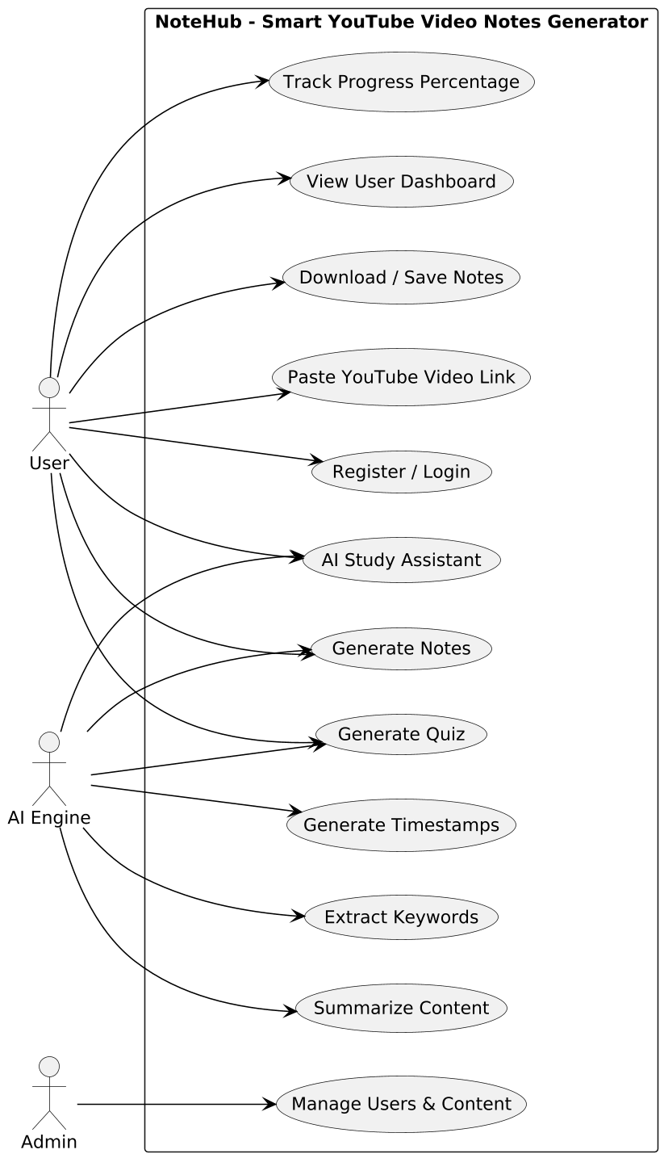
Figure 3. 1: Use Case Diagram
Description:
The Use Case Diagram provides a high-level view of the NoteHub system by showing how different actors interact with the system to perform various functions. It clearly defines the system boundary and identifies the main actors, such as the User and the Admin, who interact with NoteHub. The User actor represents students or learners who use the system to submit YouTube video links, generate structured notes, attempt quizzes, track their learning progress, and interact with the AI study assistant. The Admin actor represents the system administrator who manages users and oversees system operations. Each use case in the diagram represents a specific service provided by the system, such as user authentication, video link submission, transcript extraction, note generation, quiz creation, and progress tracking. The diagram also shows relationships between actors and use cases, helping to understand which actor is responsible for initiating each function. By visualizing these interactions, the Use Case Diagram helps clarify functional requirements and ensures that all required system features are included. This diagram plays an important role in system design by serving as a bridge between user requirements and detailed system design. It helps developers understand system behavior from the user’s perspective and supports the creation of other UML diagrams such as class diagrams, sequence diagrams, and activity diagrams. Overall, the Use Case Diagram provides a clear and structured overview of the system’s functionality, making it easier for stakeholders to understand how the NoteHub system operates. This diagram plays an important role in system design by serving as a bridge between user requirements and detailed system design. It helps developers understand system behavior from the user’s perspective and supports the creation of other UML diagrams such as class diagrams, sequence diagrams, and activity diagrams. Overall, the Use Case Diagram provides a clear and structured overview of the system’s functionality, making it easier for stakeholders to understand how the NoteHub system operates and how each actor interacts with the system. By visualizing these interactions, the Use Case Diagram helps clarify functional requirements and ensures that all required system features are included. It also assists in identifying missing or redundant functionality at an early stage of development. The diagram serves as a reference for developers when implementing system features and for testers when validating system behavior. Furthermore, it improves communication between stakeholders by presenting system functionality in an easy-to-understand graphical form. This diagram plays an important role in system design by serving as a bridge between user requirements and detailed system design.

3.3 SYSTEM ANALYSIS (USE CASE MODEL)
Table 3. 1: Use Case — User Registration
Attribute | Description
Use Case ID | UC-01
Use Case Name | User Registration
Primary Actor | User (Student)
Description | This use case allows a new user to create an account in the NoteHub system to access all learning features such as note generation, quizzes, and progress tracking.
Preconditions | User has access to the internet and NoteHub website.
Postconditions | User account is successfully created and stored in the system database.
Main Flow | 1. User opens the registration page.  2. User enters name, email, and password.  3. System validates the entered information.  4. System creates a new user account.  5. System displays a successful registration message.
Alternative Flow | If invalid or incomplete data is entered, the system displays an error message and asks the user to correct the information.
Exceptions | If the email already exists, the system informs the user that the account already exists.
Table 3. 2: Use Case — User Login
Attribute | Description
Use Case ID | UC-02
Use Case Name | User Login
Primary Actor | User (Student)
Description | This use case allows a registered user to log into the NoteHub system and access the dashboard.
Preconditions | User account exists in the system.
Postconditions | User is successfully logged in and redirected to the dashboard.
Main Flow | 1. User opens the login page.  2. User enters email and password.  3. System verifies credentials.  4. System grants access to the dashboard.
Alternative Flow | If incorrect credentials are entered, the system displays an error essage.
Exceptions | If the system authentication service is unavailable, login is temporarily disabled.
Table 3. 3: Use Case — Submit YouTube Video Link
Attribute | Description
Use Case ID | UC-03
Use Case Name | Submit YouTube Video Link
Primary Actor | User (Student)
Secondary Actor | YouTube Data API
Description | Allows the user to submit a YouTube educational video link to start the smart note
Preconditions | User is logged in and video is public.
Postconditions | Video metadata is retrieved and transcript extraction begins.
Main Flow | User submits URL → system validates → metadata retrieved.
Alternative Flow | Invalid or private video → error message.
Exceptions | API failure or rate limit exceeded.
Table 3. 4: Use Case — Extract Transcript
Attribute | Description
Use Case ID | UC-04
Use Case Name | Extract Transcript
Primary Actor | System
Secondary Actor | YouTube Data API
Description | Extracts transcript from the submitted YouTube video for AI processing.
Preconditions | Valid video link submitted.
Postconditions | Transcript stored successfully.
Main Flow | System requests transcript → receives → stores it.
Alternative Flow | Transcript unavailable → user notified.
Exceptions | API service unavailable.
Table 3. 5: Use Case — Text Cleaning and Preprocessing
Attribute | Description
Use Case ID | UC-05
Use Case Number | Text Cleaning and Preprocessing
Primary Actor | System
Description | Cleans the extracted transcript by removing unnecessary words and formatting issues.
Preconditions | Transcript is available.
Postconditions | Cleaned text ready for AI processing.
Main Flow | System removes noise → organizes text → prepares input.
Alternative Flow | Minor text issues handled automatically.
Exceptions | Processing error due to corrupted text.
Table 3. 6: Use Case — Generate AI-Based Notes
Attribute | Description
Use Case ID | UC-06
Use Case Name | Generate AI-Based Notes
Primary Actor | System
Secondary Actor | AI Service
Description | Generates structured study notes from the processed transcript using AI.
Preconditions | Clean transcript available.
Postconditions | Notes generated and saved.
Main Flow | System sends text to AI → notes generated → saved.
Alternative Flow | Partial notes generated if content is limited.
Exceptions | AI service unavailable.
Table 3. 7: Use Case — Keyword Extraction
Attribute | Description
Use Case ID | UC-07
Use Case Name | Keyword Extraction
Primary Actor | System
Description | Extracts important keywords from generated notes for quick revision.
Preconditions | Notes generated.
Postconditions | Keywords displayed with notes.
Main Flow | System analyzes notes → extracts keywords.
Alternative Flow | Fewer keywords extracted for short content.
Exceptions | Keyword extraction fails.
Table 3. 8: Use Case — Generate Quiz
Attribute | Description
Use Case ID | UC-08
Use Case Name | Generate Quiz
Primary Actor | System
Secondary Actor | AI Service
Description | Generates quiz questions from AI-generated notes.
Preconditions | Notes available.
Postconditions | Quiz created and saved.
Main Flow | System sends notes → AI creates quiz → quiz stored.
Alternative Flow | Quiz generated with limited questions.
Exceptions | AI service failure.
Table 3. 9: Use Case — Attempt Quiz
Attribute | Description
Use Case ID | UC-09
Use Case Name | Attempt Quiz
Primary Actor | User (Student)
Description | Allows user to attempt quiz and receive feedback.
Preconditions | Quiz exists.
Postconditions | Score calculated and saved.
Main Flow | User attempts quiz → submits answers → system evaluates.
Alternative Flow | Incomplete quiz submission.
Exceptions | Evaluation error.
Table 3. 10: Use Case — Track Learning Progress
Attribute | Description
Use Case ID | UC-10
Use Case Name | Track Learning Progress
Primary Actor | User (Student)
Description | Displays learning progress based on notes and quizzes.
Preconditions | User activity exists.
Postconditions | Progress percentage updated.
Main Flow | System calculates progress → displays it.
Alternative Flow | No activity → progress = 0%.
Exceptions | Data retrieval failure.
Table 3. 11: Use Case — AI Study Assistant
Attribute | Description
Use Case ID | UC-11
Use Case Name | AI Study Assistant
Primary Actor | User (Student)
Secondary Actor | AI Service
Description | Allows users to ask questions and get AI-based explanations related to notes.
Preconditions | Notes exist.
Postconditions | Answer displayed to user.
Main Flow | User asks question → AI generates response.
Alternative Flow | Generic explanation provided.
Exceptions | AI unavailable.
Table 3. 12: Use Case — User Dashboard Management
Attribute | Description
Use Case ID | UC-12
Use Case Name | User Dashboard Management
Primary Actor | User (Student)
Description | Allows user to manage videos, notes, quizzes, and downloads from dashboard.
Preconditions | User logged in.
Postconditions | Dashboard data updated.
Main Flow | User opens dashboard → selects content → manages data.
Alternative Flow | Empty dashboard for new users.
Exceptions | Data loading error.
Table 3. 13: Use Case — Admin Login
Attribute | Description
Use Case ID | UC-13
Use Case Name | Admin Login
Primary Actor | Admin
Description | Allows admin to access system management features.
Preconditions | Admin account exists.
Postconditions | Admin logged in successfully.
Main Flow | Admin enters credentials → system verifies → access granted.
Alternative Flow | Invalid credentials.
Exceptions | Authentication service unavailable.
Table 3. 14: Use Case — Monitor System
Attribute | Description
Use Case ID | UC-14
Use Case Name | Monitor System
Primary Actor | Admin
Description | Allows admin to monitor system performance and usage.
Preconditions | Admin logged in.
Postconditions | System status viewed.
Main Flow | Admin views system logs and usage.
Alternative Flow | Limited monitoring during maintenance.
Exceptions | Log retrieval failure.
Table 3. 15: Use Case — Manage Users
Attribute | Description
Use Case ID | UC-15
Use Case Name | Manage Users
Primary Actor | Admin
Description | Allows admin to manage user accounts if required.
Preconditions | Admin logged in.
Postconditions | User account updated.
Main Flow | Admin views users → updates status.
Alternative Flow | No users available.
Exceptions | Database update failure.

CHAPTER 4 – DESIGN

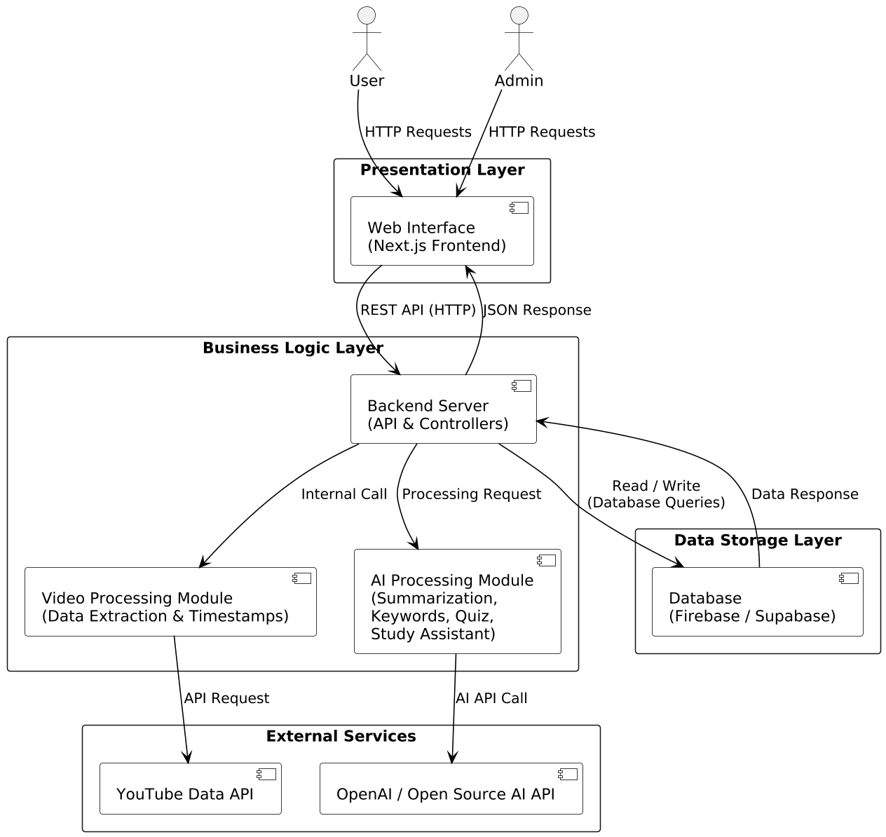
4.1.1 Architecture Diagram
4. 1: Architecture Diagram
Explanation:
The architecture of the NoteHub system is based on a client–server web application model, which separates the system into different layers to improve clarity, performance, and maintainability. This design allows users to interact with the system through a web browser while all processing and data handling are performed on the server side. The architecture follows a layered approach that includes the presentation layer, application layer, and data storage layer. The presentation layer consists of the frontend interface accessed through a web browser. It provides features such as user registration, login, submission of YouTube video links, viewing generated notes, attempting quizzes, and monitoring learning progress. The frontend focuses on user interaction and sends requests to the backend using secure HTTP or HTTPS communication. It also displays responses received from the backend in a user-friendly manner. The application layer is implemented as a backend API and serves as the core of the NoteHub system. This layer is responsible for validating user input, managing authentication, and handling business logic. When a YouTube video link is submitted, the backend validates the link, extracts the video identifier, and retrieves the video transcript. The extracted transcript is then preprocessed by cleaning, formatting, and preparing the text for further analysis. After preprocessing, the backend communicates with AI services to generate structured notes, extract important keywords, create quizzes, and provide AI-based study assistance. These AI services help transform raw video content into meaningful learning material. The backend also coordinates data flow between the frontend, AI services, and database to ensure smooth and reliable system operation. The data storage layer is responsible for maintaining persistent data used by the system. It stores user account information, submitted video details, processed transcripts, generated notes, quizzes, quiz attempts, and progress records. The backend interacts with the database using structured queries to store and retrieve data efficiently and securely. Overall, this architecture ensures a clear separation of responsibilities between system components. It improves scalability by allowing each layer to be extended independently, enhances security by controlling access at the backend, and supports maintainability by organizing system functionality in a structured manner. Logging and monitoring mechanisms are also used to track system activity and support maintenance

4.1.2 Entity Relationship Diagram
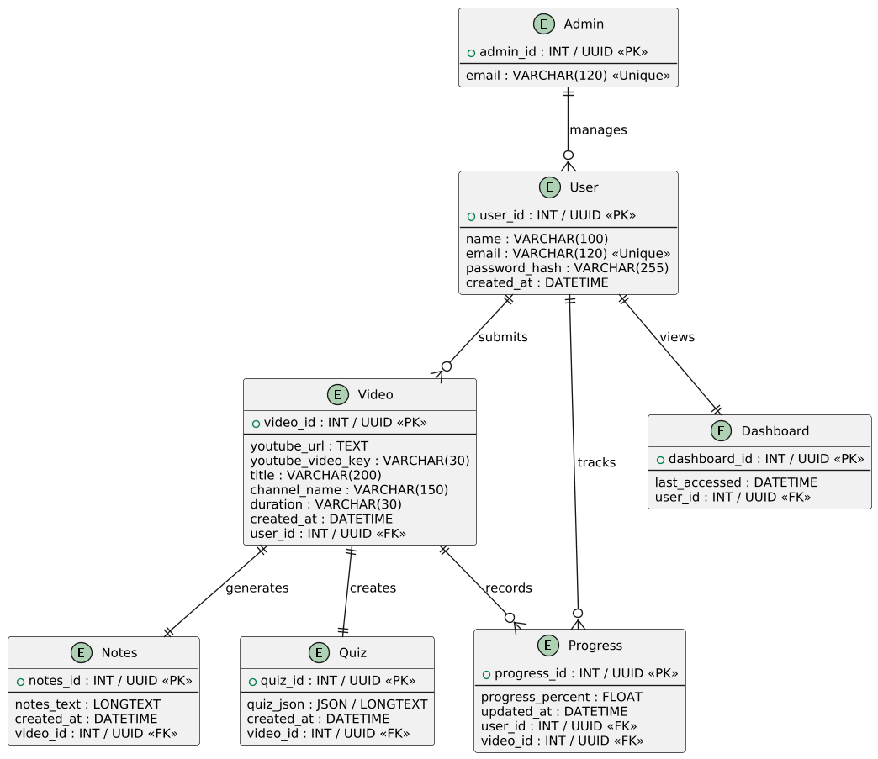
Figure 4.2: Entity Relationship Diagram

Explanation
The Entity Relationship Diagram (ERD) represents the database structure of the NoteHub system and explains how data is stored and related within the system. The ERD includes the main entities such as Admin, User, Video, Notes, Quiz, Dashboard, and Progress, which together support the core functionality of the application. Each entity is designed to store specific information required for system operation and user interaction. The Admin entity represents system administrators who are responsible for managing users and monitoring uploaded content. The User entity stores information about registered users who access the system to generate notes and quizzes. A user can process multiple videos, which is represented through a one-to-many relationship between the User and Video entities. This allows each user to submit and manage more than one YouTube video within the system. The Video entity stores details related to YouTube videos submitted by users. Each video acts as the main source for generating learning material. From a single video, the system generates structured notes and quizzes, which are represented by the Notes and Quiz entities. These entities are directly linked to the Video entity, showing that each video can produce one set of notes and one or more quizzes. The Progress entity tracks the learning status of users by recording progress updates based on quiz attempts and completed activities. This entity maintains a relationship with both the User and Video entities, ensuring that progress is accurately tracked for each user-video combination. Overall, the ERD clearly defines how data flows and is organized within the NoteHub system. It ensures data consistency, supports multiple users and videos, and provides a solid foundation for database implementation aligned with the system’s functional requirements.

4.1.2 Data Dictionary Table

Table 4.1: Admin
Field Name | Data Type | Key | Null? | Description
admin_id | INT / UUID | PK | No | Unique identifier for admin
email | VARCHAR(120) | Unique | No | Admin login email

Table 4.2: User
Field Name | Data Type | Key | Null? | Description
user_id | INT / UUID | PK | No | Unique user identifier
name | VARCHAR(100) | – | No | User full name
email | VARCHAR(120) | Unique | No | User email address
password_hash | VARCHAR(255) | – | No | Encrypted password
created_at | DATETIME | – | No | Account creation timestamp

Table 4.3: Video
Field Name | Data Type | Key | Null? | Description
video_id | INT / UUID | PK | No | Unique video identifier
youtube_url | TEXT | – | No | YouTube video link
youtube_video_key | VARCHAR(30) | – | No | YouTube video unique key
title | VARCHAR(200) | – | Yes | Video title
channel_name | VARCHAR(150) | – | Yes | YouTube channel name
duration | VARCHAR(30) | – | Yes | Video duration
created_at | DATETIME | – | No | Video submission time
user_id | INT / UUID | FK → User.user_id | No | Owner user

Table 4.4: Notes
Field Name | Data Type | Key | Null? | Description
notes_id | INT / UUID | PK | No | Unique notes identifier
notes_text | LONGTEXT | – | No | AI-generated notes
created_at | DATETIME | – | No | Notes generation time
video_id | INT / UUID | FK → Video.video_id | No | Related video

Table 4.5:Quiz
Field Name | Data Type | Key | Null? | Description
quiz_id | INT / UUID | PK | No | Unique quiz identifier
quiz_json | JSON / LONGTEXT | – | No | Quiz questions & answers
created_at | DATETIME | – | No | Quiz creation time
video_id | INT / UUID | FK → Video.video_id | No | Related video

Table 4.6: Progress
Field Name | Data Type | Key | Null? | Description
progress_id | INT / UUID | PK | No | Unique progress record
progress_percent | FLOAT | – | No | Completion percentage
updated_at | DATETIME | – | No | Last updated time
user_id | INT / UUID | FK → User.user_id | No | Related user
video_id | INT / UUID | FK → Video.video_id | No | Related video
Table 4.7: Dashboard
Field Name | Data Type | Key | Null? | Description
dashboard_id | INT / UUID | PK | No | Unique dashboard identifier
last_accessed | DATETIME | – | No | Last access time
user_id | INT / UUID | FK → User.user_id | No | Associated user

4.1.3 Data Flow Diagram (Level 0 and Level 1)

Data Flow Diagram Level 0 (Context Diagram)
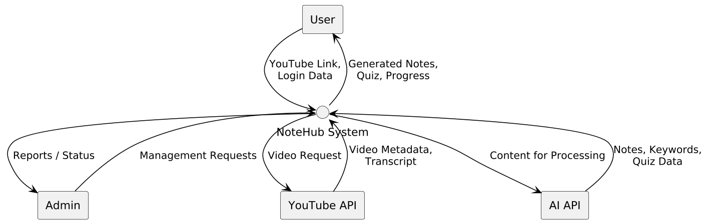
Figure 4.3: Data Flow Diagram Level 0
Explanation
The DFD Level 0, also known as the Context Diagram, represents the NoteHub system as a single high-level process and shows how it interacts with external entities. In this diagram, NoteHub is treated as one complete system that communicates with users and external services without exposing internal processing details. The purpose of this diagram is to provide an overall view of the system boundaries and the main flow of data. The User is the primary external entity who interacts with the NoteHub system. The user submits a YouTube video link to the system and requests learning support. In response, the system processes the request and provides generated notes, quizzes, and progress updates back to the user. This interaction highlights how users benefit from the system by converting video content into structured learning material. The NoteHub system also interacts with external services to perform its functions. The YouTube API is used to fetch video-related data such as metadata and transcripts based on the provided video link. The AI service processes the extracted video content to generate summaries, notes, and quiz questions. Additionally, the database and authentication services support user management, data storage, and secure access to the system. These external services enable NoteHub to function efficiently without exposing internal complexities. Overall, the DFD Level 0 diagram provides a clear and simplified overview of the NoteHub system, showing how data flows between the user, the system, and external services. It establishes the system scope and prepares the reader for more detailed data flow diagrams presented in the following sections.

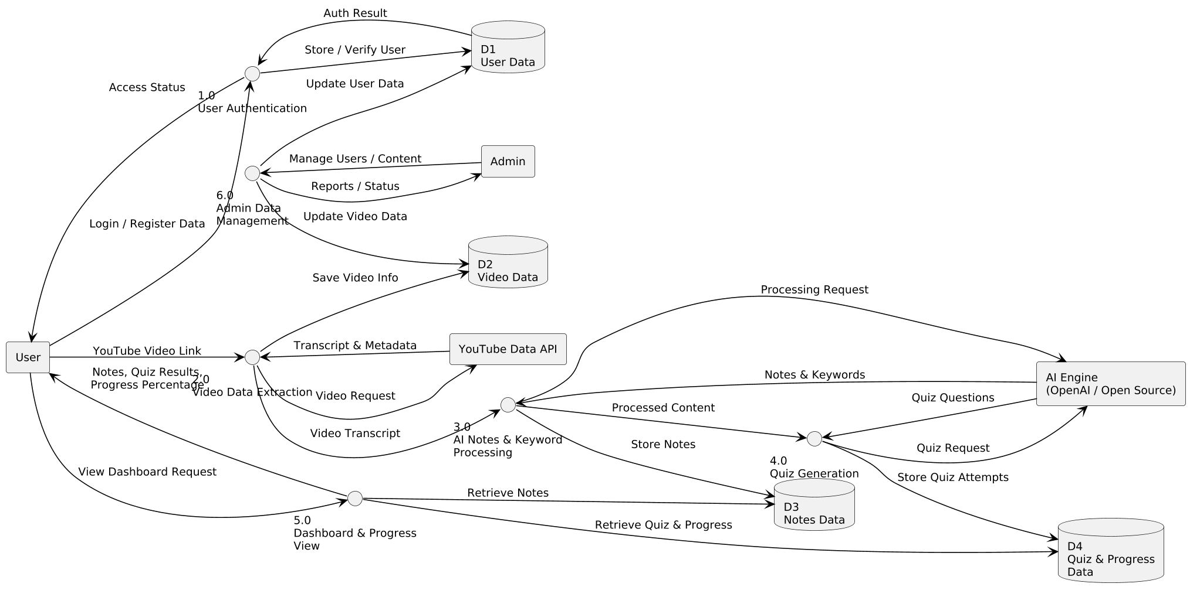
Data Flow Diagram Level 1
Figure 4.4: Data Flow Diagram Level 1

Explanation:
The Level 1 Data Flow Diagram represents the internal working of the system by dividing it into multiple sub-processes that collectively manage the core functionality. The system begins with user authentication, where users register or log in to access system features. User credentials are validated, and authorized users are granted access to submit YouTube video links and interact with learning content. This process ensures secure access to the system.
After authentication, the system processes the submitted YouTube video links. The video data is validated and relevant metadata such as the video title and duration is retrieved. The system then extracts the video transcript, which serves as the primary input for further processing. This step ensures that only valid and meaningful video data is passed to the next stages of the system.
The extracted transcript is then preprocessed to remove unnecessary data and prepare it for analysis. The cleaned text is analyzed using AI techniques to generate structured learning content. This includes the creation of summarized notes, important keywords, relevant timestamps, and quiz questions. These AI-generated outputs help transform raw video content into useful study material.
Once the quizzes are generated, users can attempt them to assess their understanding. The system evaluates user responses and records quiz attempts. Based on quiz results and user interaction, the system updates and tracks learning progress, allowing users to monitor their performance over time.
Additionally, the system includes an AI-based study assistant that supports users throughout the learning process by answering questions and providing explanations when needed. All generated content and user activity data are stored and managed efficiently to ensure consistency and availability. Overall, the DFD Level 1 illustrates how data flows through the system, showing how different processes work together to deliver an intelligent and interactive learning experience.

4.1.4 Class Diagram
Explanation:
Figure 4.6 shows the UML Class Diagram of the NoteHub system. The class diagram presents the object-oriented structure of the system by illustrating the main classes, their data members, operations, and relationships. Only essential classes are included to keep the design simple and aligned with real system behavior.. The Admin class represents the system administrator who is responsible for managing users and moderating content within the system. It contains basic information such as admin identifier and email address, along with operations that allow the admin to manage user accounts and control uploaded video content. This class ensures system integrity and proper usage. The User class represents registered users of the NoteHub system. It stores user-related information including a unique user identifier, name, email, and encrypted password. The operations defined in this class allow users to register, log in, and log out of the system. Users are the primary actors who interact with the system by submitting YouTube videos and accessing generated learning content through the dashboard.The Video class stores information related to YouTube videos submitted by users. It includes attributes such as video identifier, YouTube URL, and video title. The submitVideo operation handles the submission of video data for further processing. Each video acts as the main input source from which notes and quizzes are generated.The Notes class represents the structured notes generated from video content. It contains attributes such as notes identifier, generated content, and creation time. The generateNotes operation is responsible for producing readable study notes. This class helps transform video information into concise and meaningful learning material.The Quiz class is used to represent quizzes generated from the notes. It includes information such as quiz identifier and the total number of questions. The generateQuiz operation creates quiz questions based on the notes, allowing users to assess their understanding of content. The Progress class is responsible for tracking the learning progress of users. It stores the progress percentage and the time of the last update. The updateProgress operation updates the user’s learning status based on quiz attempts and completed activities, helping monitor overall performance. The DashboardController class manages the presentation of learning content to the user. It does not store data itself but provides operations to view notes, quizzes, and progress. This class acts as a controller that connects users with the system’s learning data in an organized manner. The relationships in the diagram show how the system operates as a whole. The Admin class manages users and moderates videos. Users submit videos, which are used to generate notes. Notes are then used to create quizzes, and quiz activity updates user progress. Users interact with the DashboardController to view notes, quizzes, and progress information. These relationships demonstrate how data flows between classes and how the system components work together to deliver learning functionality.
Diagram:
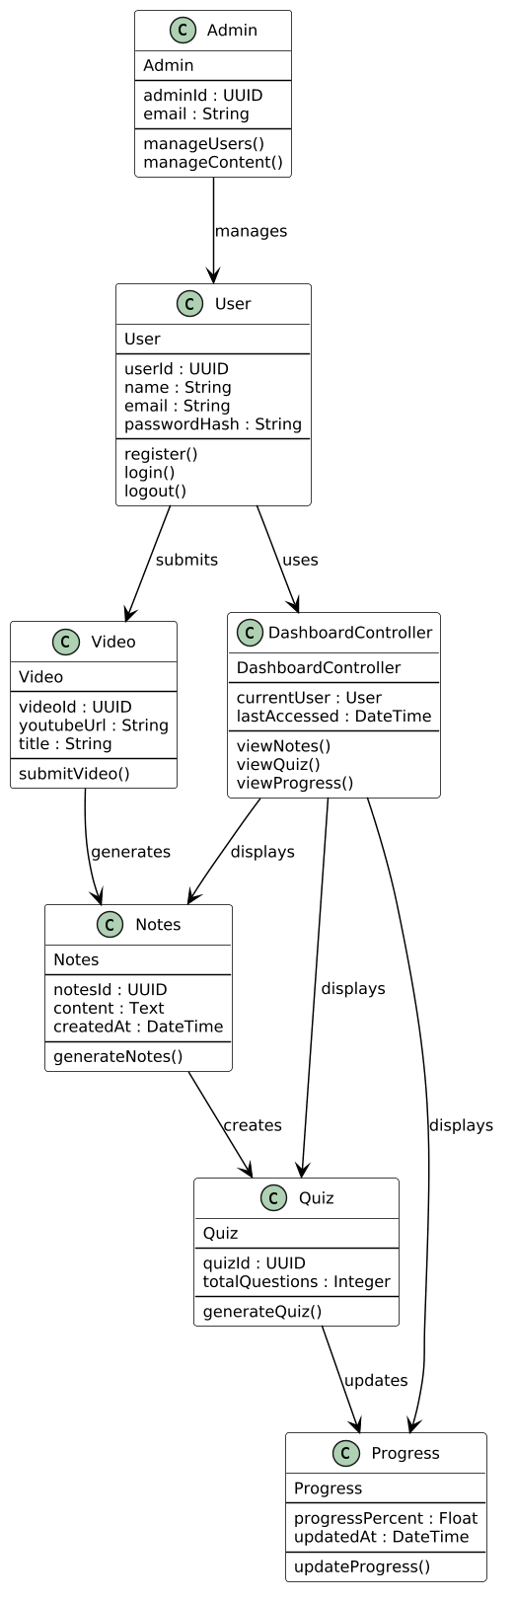

Figure 4. 5: Class Diagram

4.1.5 Object Diagram
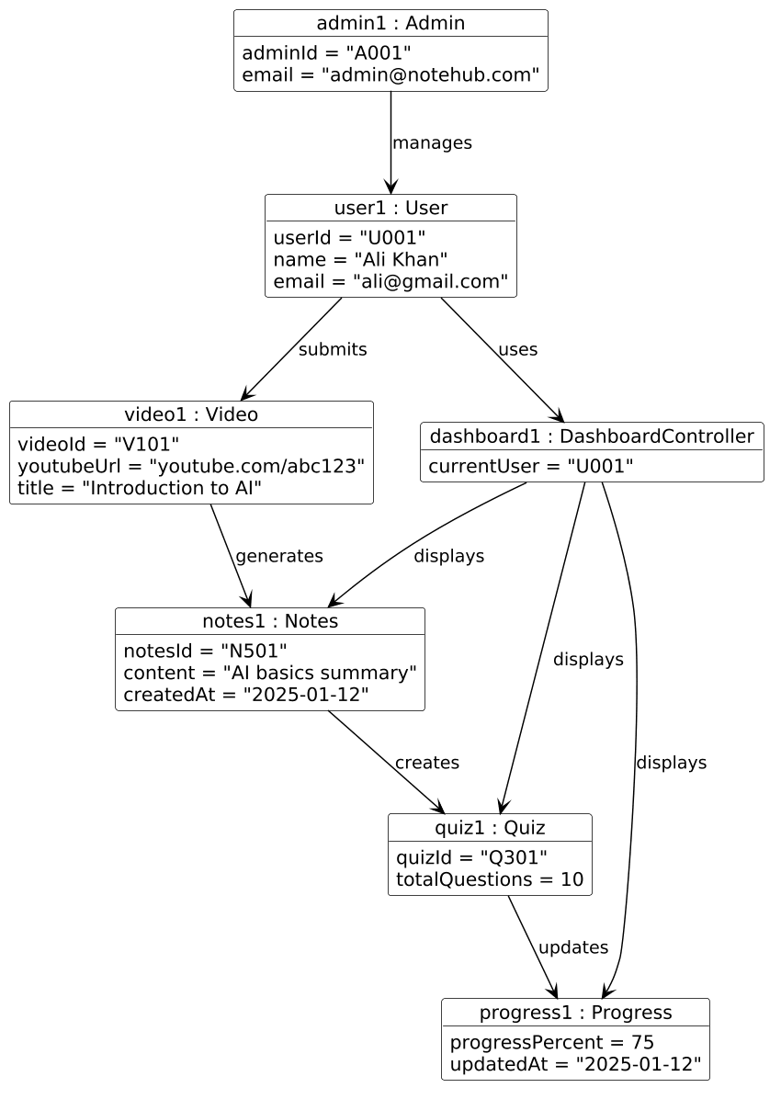
Figure 4. 6: Object Diagram
Explanation: The diagram represents a runtime snapshot of the NoteHub system, showing how different components interact with each other during actual system execution. At this particular moment, the system is being used by both an administrator and a registered user. Admin1 plays an important supervisory role in the system by managing users and monitoring the overall content flow. The administrator ensures that the platform is being used properly, users are valid, and uploaded content follows system rules. This role is essential for maintaining the reliability and smooth operation of the system. In this execution scenario, User1 is an active user of the NoteHub system. After logging into the system, User1 submits Video1, which is a YouTube video link intended for learning purposes. The submitted video becomes the main input for the system’s processing workflow. Once the video is submitted, the system begins transforming the video content into educational resources. The video information, such as title and content, is used to generate structured learning material. From Video1, the system generates Notes1, which represent AI-generated, well-organized notes extracted from the video content. These notes help the user understand the topic more easily by summarizing important concepts in a readable form. The creation of Notes1 demonstrates how the system converts raw video content into meaningful study material. This step is crucial because it allows users to learn efficiently without watching the entire video repeatedly. After the notes are generated, the system uses Notes1 to create Quiz1. The quiz is designed to test the user’s understanding of the topic covered in the video and notes. Quiz1 contains multiple questions related to the learning content and allows the user to evaluate their knowledge. This step shows how learning assessment is integrated into the system to improve user engagement and learning effectiveness. Once the user attempts the quiz, the system evaluates the responses and updates Progress1. The Progress object stores information such as completion percentage and learning status. It reflects how much the user has learned and how well they performed in the quiz. This progress tracking feature helps users monitor their learning journey and motivates them to improve their performance over time. Throughout this entire process, Dashboard1 acts as the main interface through which User1 interacts with the system. The dashboard displays notes, quiz results, and progress information in an organized manner. Instead of accessing each component separately, the user can view all learning-related data through the dashboard. This makes the system more user-friendly and efficient. Overall, this runtime snapshot clearly demonstrates how the NoteHub system operates during execution. It shows the complete flow starting from administrative control, user interaction, video submission, content generation, assessment, progress tracking, and final visualization through the dashboard. The diagram effectively illustrates how different system objects collaborate at runtime to provide a complete learning experience. This explanation helps in understanding how the static class design is transformed into real system behavior during actual use.

4.1.6 Sequence Diagram
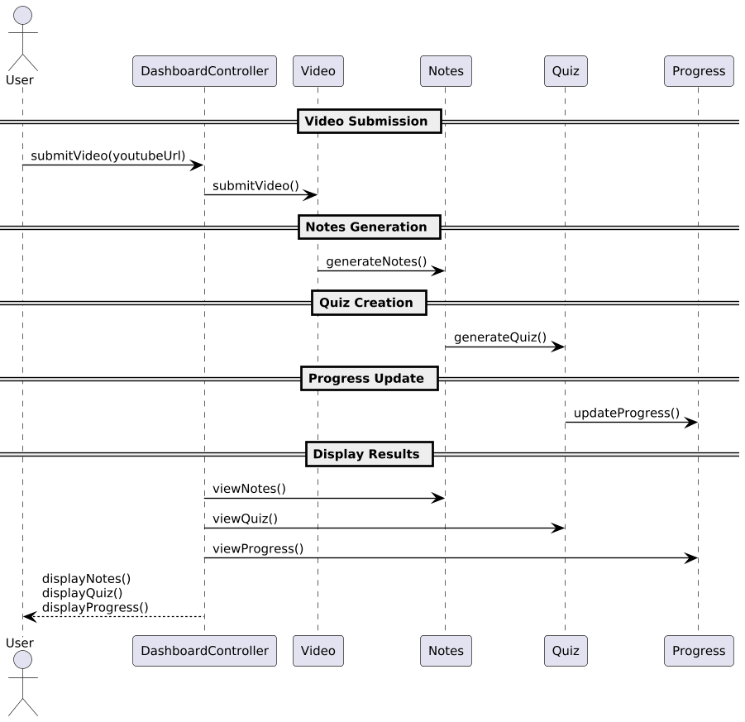
Figure 4.7: Sequence Diagram
Explanation:
The sequence diagram represents the dynamic behavior of the NoteHub system by showing how different system components interact with each other over time when a user submits a YouTube video. Unlike static diagrams, this diagram focuses on the order of actions and messages exchanged between the user and the system. It provides a clear understanding of how the system operates during real execution, from the initial user request to the final display of results on the dashboard. The sequence starts when the user logs into the system and submits a YouTube video link for learning purposes. This action triggers the system to receive and validate the provided video URL. Once the video link is accepted, the system creates a video record and begins processing the video content. This step ensures that the video information is properly handled before any learning material is generated. After the video is successfully processed, the system generates structured notes based on the video content. These notes are designed to summarize the main ideas of the video in a clear and understandable format so that the user can easily study the topic. The notes generation process is automatic and forms the foundation for further learning activities within the system. Once the notes are generated, the system proceeds to create a quiz related to the same video. The quiz generation step uses the generated notes to prepare relevant questions that help assess the user’s understanding of the topic. This ensures that the quiz content remains consistent with the learning material provided in the notes. Following the quiz generation, the system updates the user’s learning progress. The progress update reflects the completion of content generation and prepares the system to track user performance when the quiz is attempted. This step is important because it allows the system to monitor learning status and maintain accurate progress records for each user. Finally, the dashboard component retrieves the generated notes, quiz details, and updated progress information from the system. This information is then displayed to the user in an organized and user-friendly manner. The user can view the notes for study, attempt the quiz, and check learning progress through the dashboard interface. This completes one full interaction cycle of the system. Overall, the sequence diagram clearly explains the time-ordered flow of operations in the NoteHub system. It demonstrates how a single user request leads to multiple coordinated system actions, including video handling, notes generation, quiz creation, progress tracking, and result presentation. This diagram helps in understanding system behavior, validating functional requirements, and ensuring that all components work together smoothly to provide an effective learning experience.

4.1.7 Activity Diagram
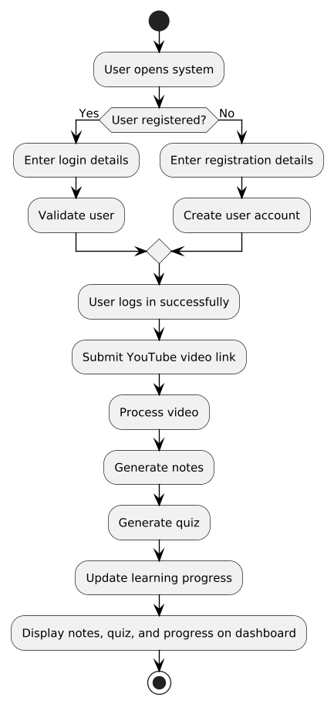

Figure 4. 8: Activity Diagram
Explanation:
The Activity Diagram illustrates the complete workflow of the NoteHub system by showing how activities are performed step by step during system execution. It uses swimlanes to clearly separate user actions from system-level processing, making it easy to understand which activities are performed by the user and which are handled automatically by the system. This diagram provides a dynamic view of how the system behaves from the moment a user accesses the application until the final learning content is displayed. The workflow begins when the user opens the system and chooses to either log in or register. If the user is new, the registration activity is performed where basic user information is provided and stored by the system. Existing users proceed through the login activity by entering their credentials. The system validates these credentials and, upon successful authentication, grants access to the main dashboard. If authentication fails, the user is prompted to re-enter correct information. Once logged in, the user submits a YouTube video link through the dashboard. This action marks the start of the content processing phase. The system receives the video link and automatically extracts the required video information. This includes fetching video metadata and preparing the video content for further processing. The user does not need to perform any additional action during this stage, as all operations are handled internally by the system. After extracting video data, the system initiates automated note generation. The video content is analyzed and converted into structured, readable notes. Following this, the system automatically generates a quiz based on the generated notes. This quiz is designed to assess the user’s understanding of the video content. Both notes and quizzes are generated without manual intervention, highlighting the intelligent and automated nature of the system. Once the quiz is generated and attempted by the user, the system calculates the user’s performance and updates the learning progress. The progress update activity records completion percentage and learning status, ensuring that the user’s advancement is tracked accurately. This information is stored and continuously updated as the user interacts with more content. Finally, the system displays the generated notes, quiz results, and updated progress on the user dashboard. The user can view all learning materials in one place, making the system user-friendly and efficient. The activity diagram ends when the user reviews the content or logs out of the system. Overall, this activity diagram clearly demonstrates how user interactions and system processes work together in a structured sequence to deliver automated learning support within the NoteHub system.

4.1.8 Collaboration / Communication Diagram
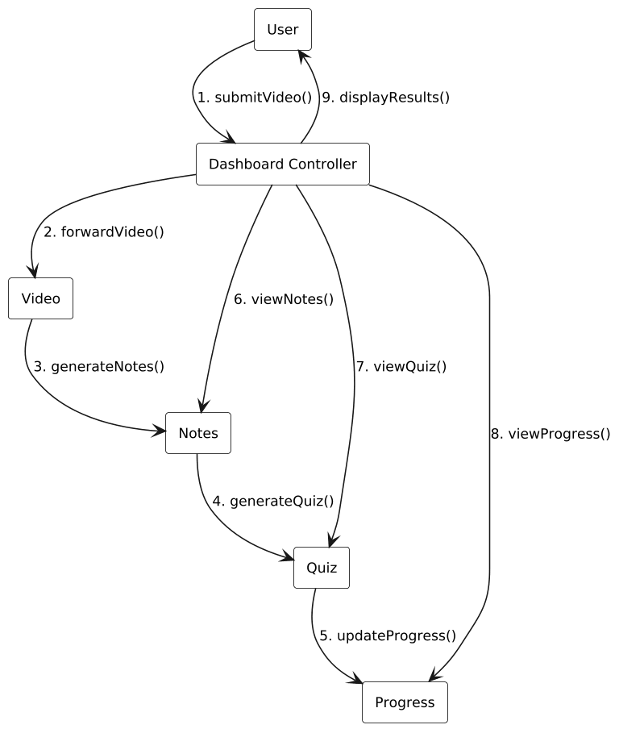
Figure 4.9: Communication Diagram
Explanation:
The Collaboration (also known as Communication) Diagram represents how different system components interact with each other through message exchanges during the execution of a specific scenario. In the NoteHub system, this diagram focuses on block-wise collaboration among objects and clearly shows how messages are passed in a numbered sequence, starting from video submission and ending with the display of results to the user. Unlike structural diagrams, this diagram emphasizes communication flow and interaction structure rather than internal data storage. The interaction begins when the User submits a YouTube video link to the system. This action triggers the first message sent to the Video component, which is responsible for handling video-related information. The Video object then communicates with the Notes component to initiate the generation of structured notes from the submitted video content. These interactions are represented through numbered messages, which indicate the order in which communication occurs between system objects. After the notes are generated, the Notes object collaborates with the Quiz component by sending the generated content for quiz creation. This step highlights how learning material flows from one component to another in a coordinated manner. The Quiz object processes the received information and generates questions to assess the user’s understanding. Once the quiz is completed or evaluated, the Quiz component sends a message to the Progress component to update the user’s learning progress based on performance. Throughout this process, the DashboardController plays an important role in coordinating communication between the user and the system components. It receives requests from the user to view notes, quiz results, and progress status, and then sends appropriate messages to the respective components to retrieve this information. The retrieved results are finally communicated back to the user through the dashboard interface, completing the interaction cycle. Overall, the Collaboration / Communication Diagram provides a clear visualization of how system components work together during runtime. By using numbered messages and direct links between objects, the diagram helps in understanding the interaction logic, execution sequence, and responsibility of each component. This diagram effectively complements the class and sequence diagrams by offering a compact yet detailed view of communication flow within the NoteHub system, ensuring clarity in system design and implementation.

4.1.9 State Transition Diagram

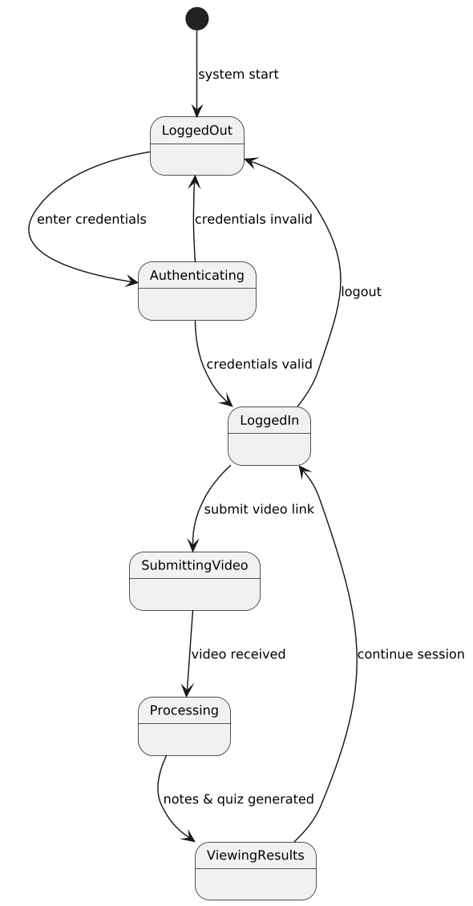
Figure 4. 10: State Transition Diagram
Explanation:
The State Transition Diagram illustrates the dynamic behavior of the NoteHub system by showing how a user session changes from one state to another in response to different system events. This diagram focuses on the flow of user interaction with the system and helps explain how the system behaves at runtime when various actions are performed by the user. Initially, the system is in the Idle state, where no user is logged in. When a user enters valid credentials, the system transitions to the Logged In state. If the login attempt fails, the system remains in the Idle state until correct credentials are provided. Once logged in successfully, the user can submit a YouTube video link, which causes the system to move into the Video Submitted state. After the video is submitted, the system enters the Processing state. In this state, the video content is analyzed, notes are generated, and a quiz is created based on the processed content. During processing, the user cannot perform other actions related to the same video, ensuring data consistency. When processing is completed successfully, the system transitions to the Results Ready state. In the Results Ready state, the user can view generated notes, attempt quizzes, and check learning progress. Each of these actions updates the user’s progress and keeps the system within this state until the user decides to perform another action. If the user submits a new video, the system transitions back to the Video Submitted and Processing states again. Finally, when the user chooses to log out, the system transitions to the Logged Out state, ending the user session and returning the system to the initial Idle state. This state transition diagram clearly demonstrates how the system responds to user actions such as login, video submission, content processing, viewing results, and logout, providing a clear understanding of the system’s dynamic behavior.

CHAPTER 5– Implementation

5.1 Component Diagram:
Explanation:
The component diagram represents the overall implementation structure of the NoteTube system and shows how different parts of the system are organized and interact with each other during execution. Unlike other diagrams such as class or sequence diagrams, this diagram focuses more on the actual software modules, services, and external systems that are used to build the application. It gives a clear idea of how the system will be developed and how different components communicate to perform various task. The system is divided into multiple layers to keep the design clean and manageable. At the top level, there is the user interface layer, which includes basic UI components such as buttons, input fields, and cards, along with the dashboard interface. These components are responsible for taking input from the user and displaying results in a structured and user-friendly way. For example, when a user enters a YouTube video link or views generated notes and quizzes, all of this interaction happens through this layer. Behind the user interface, there is the application logic layer, which acts as the brain of the system. The central part of this layer is the DashboardController, which handles user requests and coordinates the flow of data between different components. When a user submits a video link, the controller forwards the request to the video processing component. This component extracts the video ID and retrieves the transcript using the YouTube API. Once the transcript is available, it is passed to the notes component, which generates structured notes using AI. After that, the quiz component creates questions based on the generated notes to help the user test their understanding. At the same time, the progress component updates the user’s learning status based on their activity. The system also depends on external services to perform advanced operations. The YouTube API is used to fetch video transcripts, while the Gemini AI service is responsible for generating notes and quizzes. These services play an important role because they provide the intelligence and data required for the system to function effectively. Without them, the system would not be able to process video content or generate meaningful learning material. At the bottom level, there is the data layer, which consists of the Supabase database. This database stores all important information, including user data, video details, generated notes, quiz data, and progress records. It ensures that all data is saved securely and can be retrieved whenever needed. For example, when a user opens the dashboard, the controller fetches stored data from the database and displays it through the interface. Overall, the component diagram clearly shows how the system is structured and how different components work together. It provides a practical view of the system’s implementation by connecting the user interface, internal logic, external services, and database. This layered approach not only makes the system easier to understand but also helps in maintaining and scaling the application in the future.
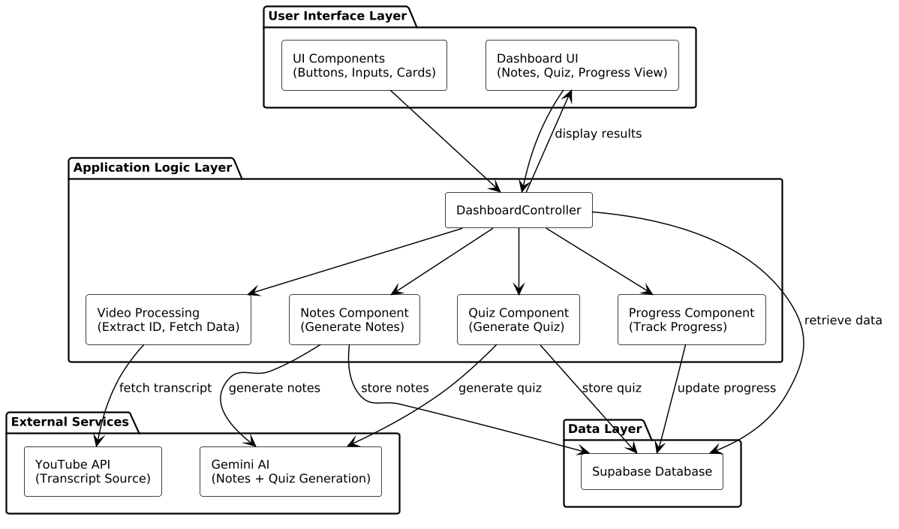
Diagram:

Figure 5.1: Component Diagram

5.2 Deployment Diagram:
Explanation: The deployment diagram shows how the NoteTube system is physically set up and where each part of the application runs. It gives a real-world view of the system by representing hardware nodes and the software components deployed on them. This diagram is closely related to the component diagram because it shows where those components are actually placed and how they communicate over a network. At the top level, the system starts with the user device, which can be a laptop, mobile phone, or tablet. The user interacts with the application through a web browser. The frontend of the system is built using Next.js, which provides the user interface for entering a YouTube link, viewing notes, attempting quizzes, and checking progress. All user actions originate from this node. The request from the user is then sent to the cloud server, which in this case is hosted on Vercel. This server runs the backend logic using Next.js API routes. It acts as the main processing unit of the system. When a request is received, the server handles different operations such as processing the video link, managing data flow, and coordinating with external services. This layer is responsible for executing the core functionality of the system. To extract video content, the server communicates with the YouTube server using the YouTube API. This allows the system to fetch the transcript of the video. Once the transcript is available, the server sends it to the Gemini AI service. The AI processes the text and generates structured notes and quiz questions. This step is important because it adds intelligence to the system and transforms raw data into useful learning material. All the generated data, including notes, quiz results, and user progress, is stored in the Supabase cloud database. This database ensures that user information is securely stored and can be accessed later. It also helps in maintaining user history and supporting features like dashboards and analytics. Finally, after processing is complete, the server sends the response back to the user device. The frontend displays the results in an organized way through the dashboard. The user can then read notes, attempt quizzes, and track progress. Overall, the deployment diagram clearly shows how different parts of the system are distributed across multiple nodes, including the client device, cloud server, database, and external services. This structure improves performance by distributing workload, supports scalability by using cloud infrastructure, and makes the system easier to maintain and extend in the future.

Diagram:
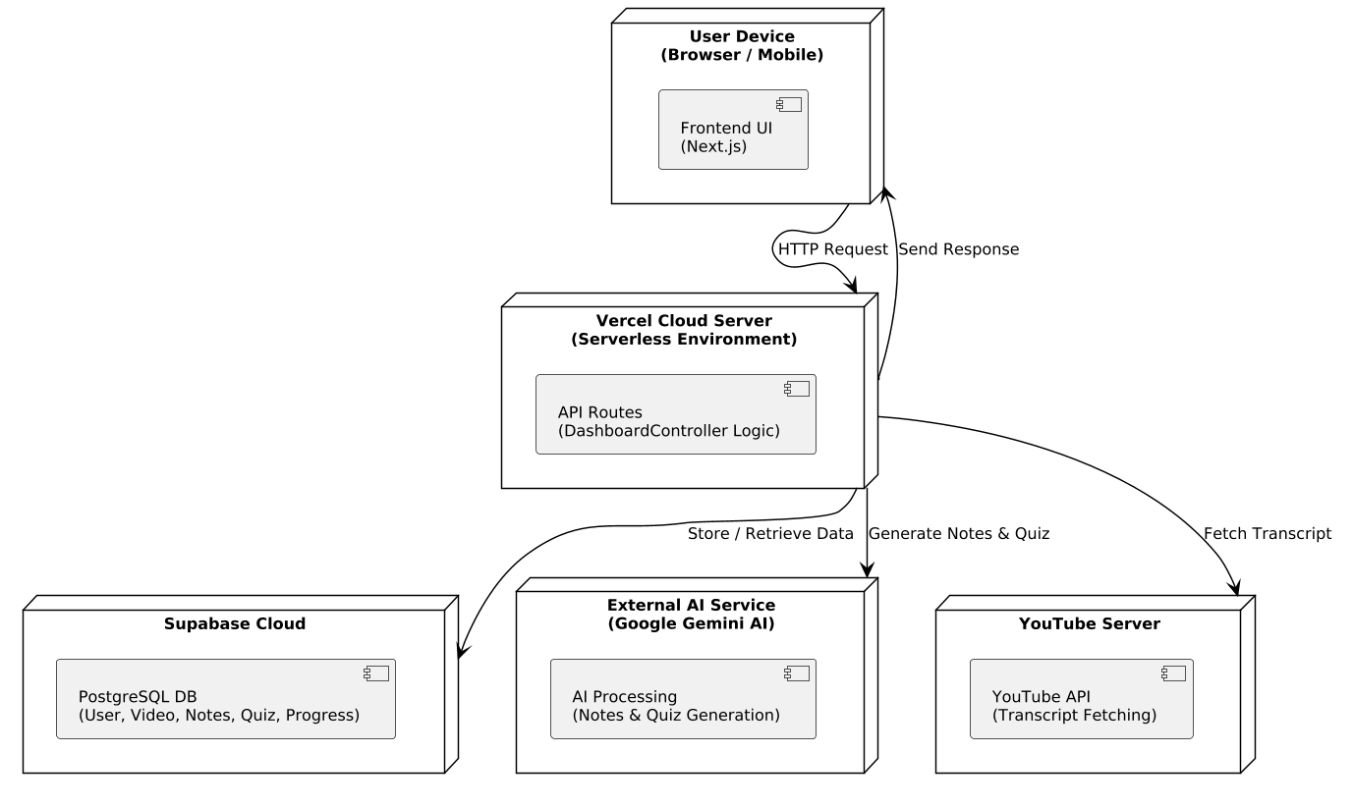

Figure 5.2: Deployment Diagram

